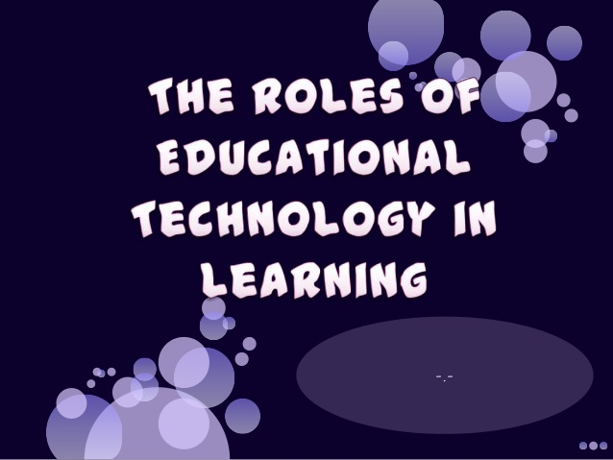
“Technology makes the world a new place”
Traditional old, classic, customary.
Traditional role:
As delivery vehicle for instructional lessons.
Traditional way:
Technology serves as a teacher.
Constructivist new.
Constructivist role:
Partners in the learning process.
Constructivist way: Technology is a learning tool to learn with not from.

From a constructivist perspective, the following are roles of technology in learning; (Jonassen, et al 1999).

Technology as tools to support knowledge construction.
Technology as information vehicles for exploring knowledge to support learning- by-constructing.
Technology as context to support learning by doing.
Technology as a social medium to support learning by conversing.
Technology as intellectual partner (Jonassen 1996) to support learning-by-reflecting.

MULTIPLE CHOICE: Choose the letter of the best answer.
1) What are the two Roles of Educational Technology in Learning?
A) Transitional and constructist
B) Transitional and constructivist
C) Traditional and constructist
D) Traditional and constructivist
2) In the role of Educational Technology in learning, technology can play a ________ as delivery vehicle for instructional lessons?
A) Traditional way
B) Traditional role
C) Constructivist way
D) Constructivist approach
3) In the role of Educational Technology in learning, technology can play a ________ as partners in the learning process?
A) Traditional way
B) Traditional role
C) Constructivist way
D) Constructivist approach
4) What kind of Roles of Educational Technology in Learning that the learner learns from the technology and the technology serves as a teacher?
A) Traditional way
B) Traditional role
C) Constructivist way
D) Constructivist approach
5) What kind of Roles of Educational Technology in Learning that the technology is a learning tool to learn with not from?
A) Traditional way
B) Traditional role
C) Constructivist way
D) Constructivist approach
6) In the quote “Technology makes the world a new place ”. what is this mean?
A) The technology does to set the world in other place.
B) The technology helps us to make a better world.
C) The technology create a world for us.
D) The technology gives us a world with a new place.
7) Teacher Kaye presents a video presentation of how the butterfly grow and what are the name of every stage. What kind of Roles of Educational Technology did teacher Kaye present?
A) Traditional
B) Transitional
C) Constructist
D) Constructivist

8) Teacher Rey presents a video presentation about the step by step procedure of how to plant trees and the student will do planting. . What kind of Roles of Educational Technology did teacher Rey present?
A) Traditional
B) Transitional
C) Constructist
D) Constructivist

9) Teacher Vane presents a video presentation about how to wash the dishes. What kind of Constructivist perspective by Jonassen did teacher Vane present?
A) Technology as tools to support knowledge construction.
B) Technology as context to support learning-by-doing.
C) Technology as a social medium to support learning by conversing.
D) Technology as intellectual partner (Jonassen 1996) to support learning-by-reflecting.

10) Rose Montemayor a student and a class president in Grade 6, share to her classmate her strategies on how she reviews by facebook chat. What kind of Constructivist perspective by Jonassen did teacher Vane present?
A) Technology as tools to support knowledge construction.
B) Technology as context to support learning-by-doing.
C) Technology as a social medium to support learning by conversing.
D) Technology as intellectual partner (Jonassen 1996) to support learning-by-reflecting.

11) What kind of Constructivist perspective by Jonassen that for representing learners’ ideas, understanding and beliefs.
A) Technology as tools to support knowledge construction.
B) Technology as context to support learning-by-doing.
C) Technology as a social medium to support learning by conversing
D) Technology as intellectual partner (Jonassen 1996) to support learning-by-reflecting.

12) What kind of Constructivist perspective by Jonassen that for accessing needed information.
A) Technology as tools to support knowledge construction.
B) Technology as context to support learning-by-doing.
C) Technology as information vehicles for exploring knowledge to support learning-by- constructing.
D) Technology as intellectual partner (Jonassen 1996) to support learning-by-reflecting.

13) What kind of Constructivist perspective by Jonassen that for representing beliefs, perspectives, arguments and stories of others.
A) Technology as information vehicles for exploring knowledge to support learning-by- constructing.
B) Technology as a social medium to support learning by conversing.
C) Technology as intellectual partner (Jonassen 1996) to support learning-by-reflecting.
D) Technology as context to support learning-by-doing.

14) What kind of Constructivist perspective by Jonassen that for collaborating with others.
A) Technology as tools to support knowledge construction.
B) Technology as a social medium to support learning by conversing.
C) Technology as intellectual partner (Jonassen 1996) to support learning-by-reflecting.
D) Technology as context to support learning-by-doing.

15) What kind of Constructivist perspective by Jonassen that for helping learners to articulate and represent what they know.
A) Technology as tools to support knowledge construction.
B) Technology as a social medium to support learning by conversing.
C) Technology as intellectual partner (Jonassen 1996) to support learning-by-reflecting.
D) Technology as context to support learning-by-doing.

Read the following carefully: These are two sentences in each number. Every sentence chooses if it is true or false. The choices are.
A) True and True
B) True and False
C) False and True
D) False and False
16) From the traditional point of view technology serves as source and presenter of knowledge. In constructivist approach, technology is a learning tool to learn from not with.
17) The proper implementation of technology in the classroom gives students more control of their own learning and tends to move classroom from teachers dominated environments to ones that are more learner-centered. The younger generation of teachers is admittedly better than the older generation of teachers when it comes to the use of the most recent technology, like the computer.
18) From the constructivist point of view, technology serves as source and presenter of knowledge. Technology like computer is seen as a productivity tool.
19) From the constructivist perspective, educational technology is a meaningful learning tool by serving as a learning partner. With the eruption of the INTERNET in the mid 90s, communications and multimedia have dominated the role of technology in the classroom for the past few years.
20) The use of technology in the classroom enables the teacher to don’t differentiated instruction considering the divergence of students’ readiness and interests, multiple intelligences and learning styles. Technology also helps the students become short term learners.

Answer:
1. D
2. B
3. C
4. A
5. D
6. B
7. A
8. D
9. B
10. C
11. A
12. C
13. D
14. B
15. C
16. B
17. A
18. C
19. B
20. D

